Directives & Pipes — Built-in and Custom
Task 1: Structural Directives
Goal: Control DOM structure dynamically using *ngIf, *ngFor, and *ngSwitch.
Course-list.ts:
Including Loading course trackingBycourseId and gradeStatus in the courselist
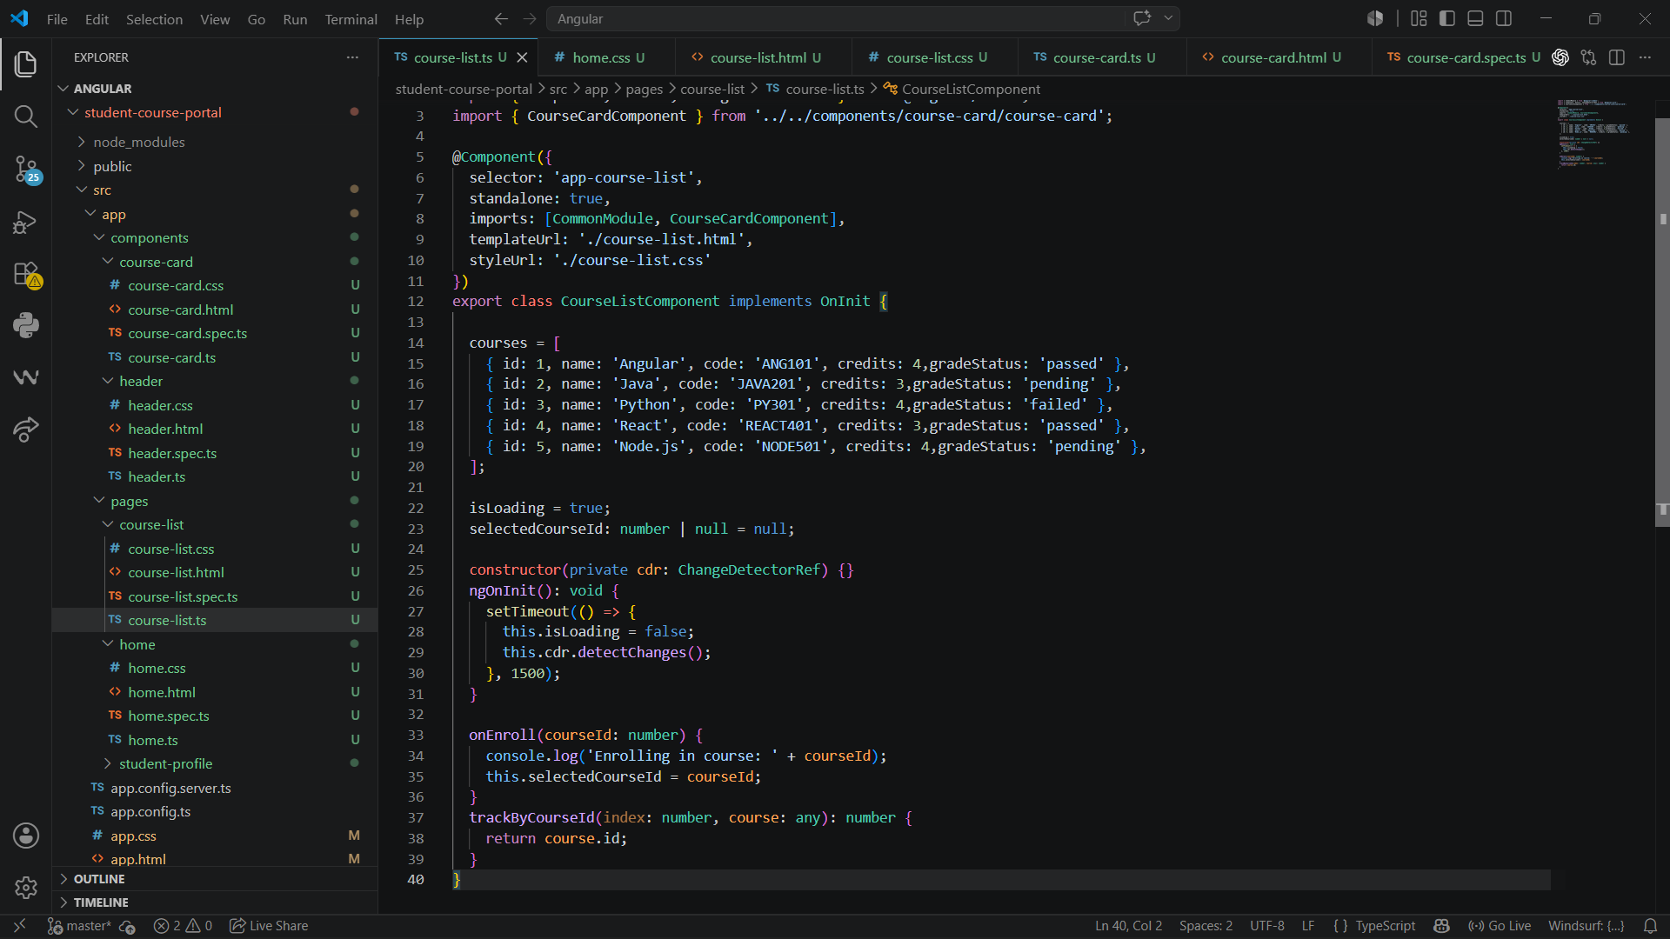
Course-card.html:
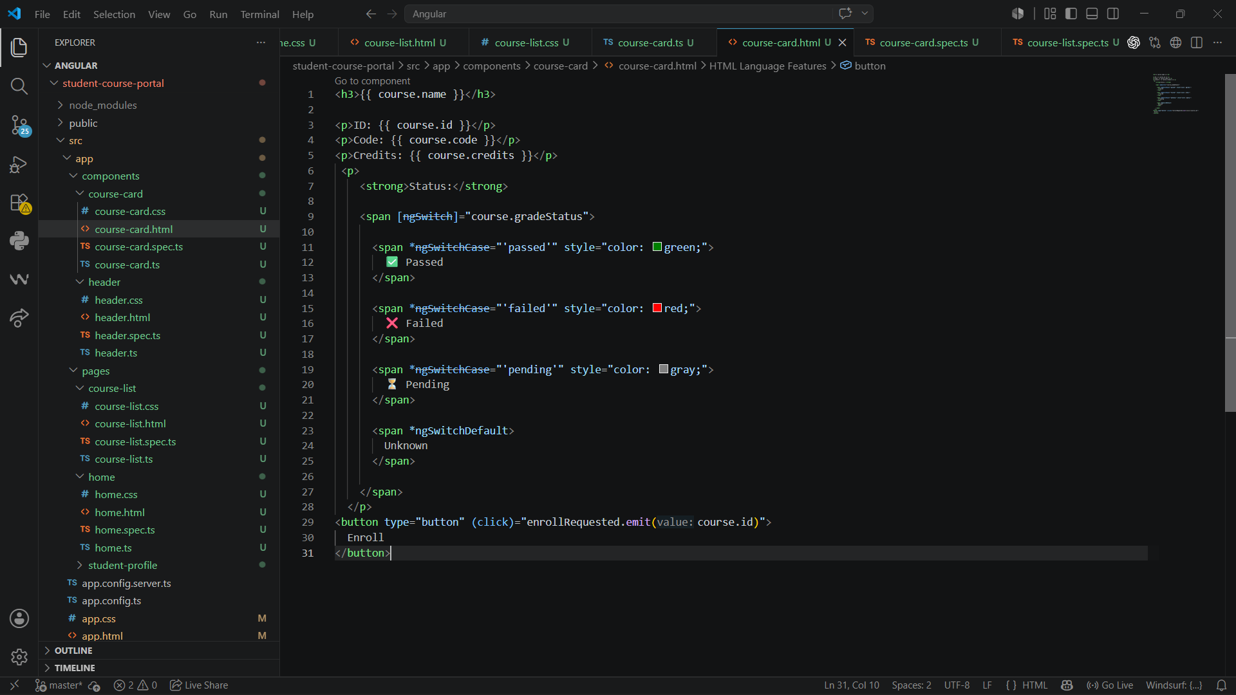

Course-list.html:
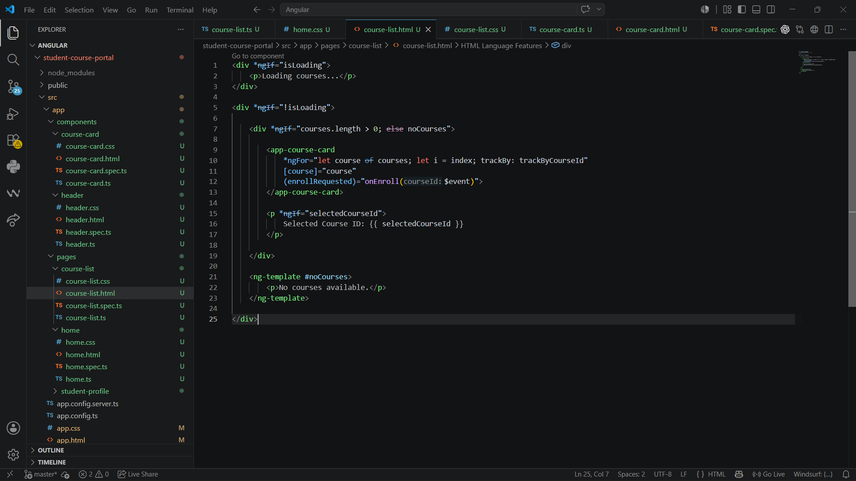
Output:
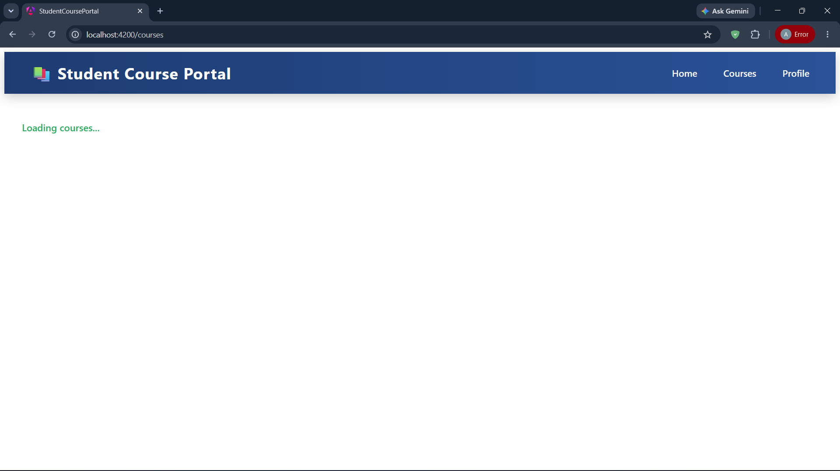
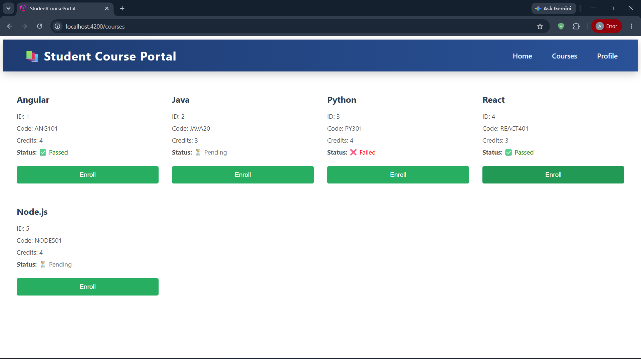
Emptied the Course List:
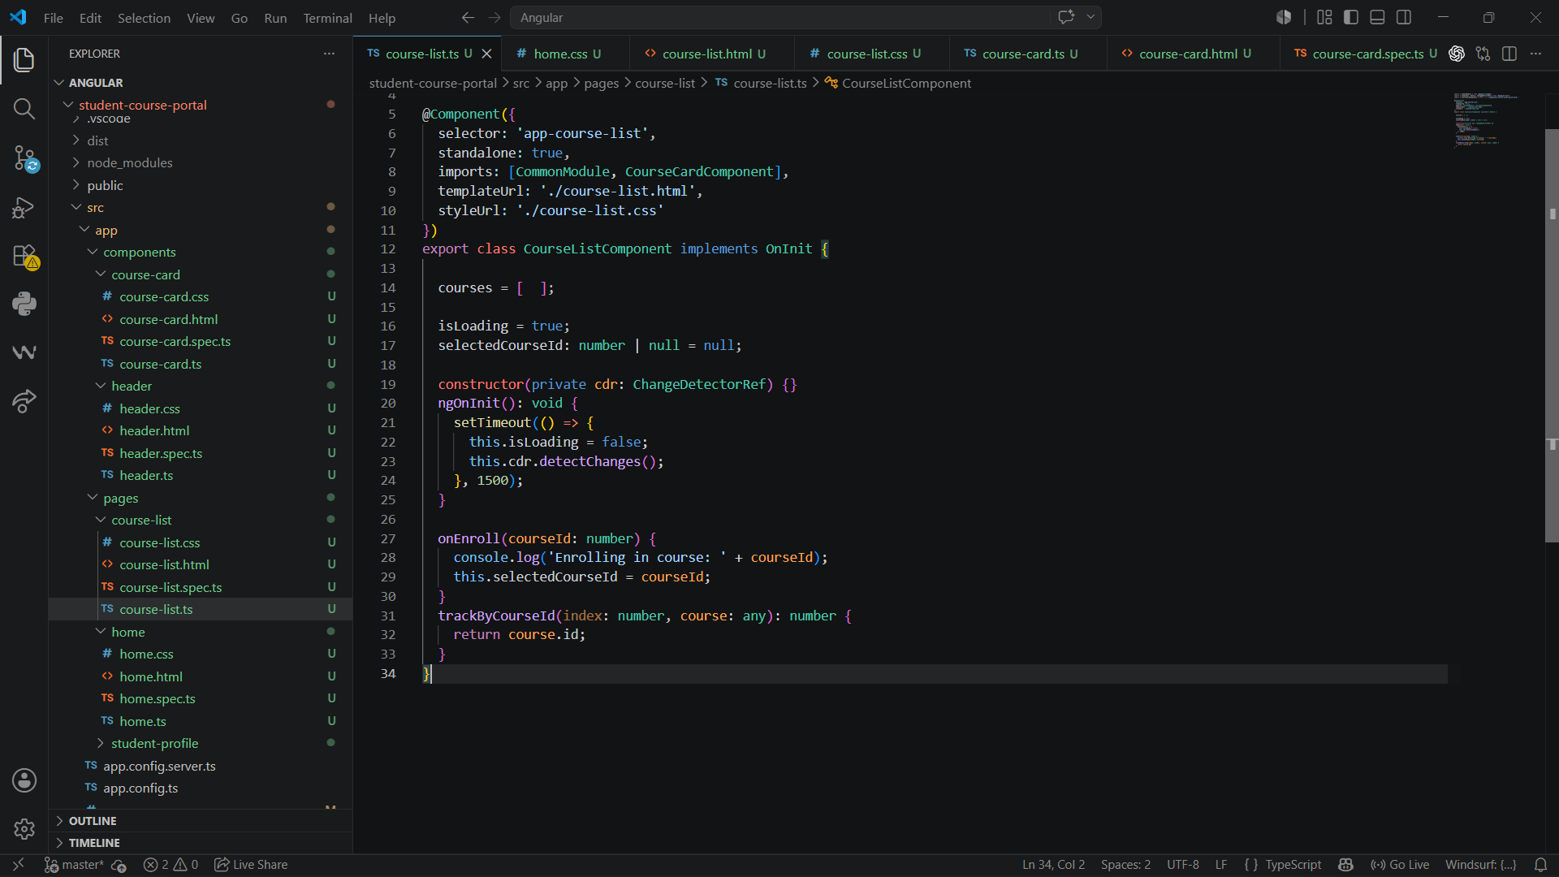

No Course available Message:
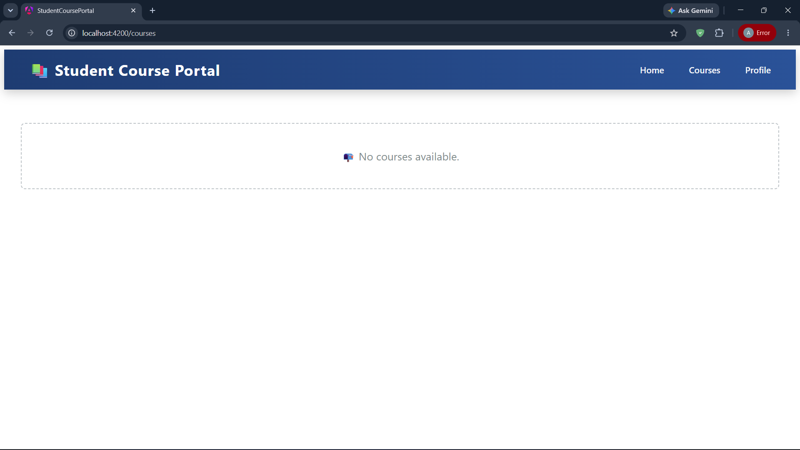
Task 2: Attribute Directives — ngClass and ngStyle
Goal: Apply dynamic CSS classes and inline styles using attribute directives.
Course-card.html:
Adding toggle for displaying Details
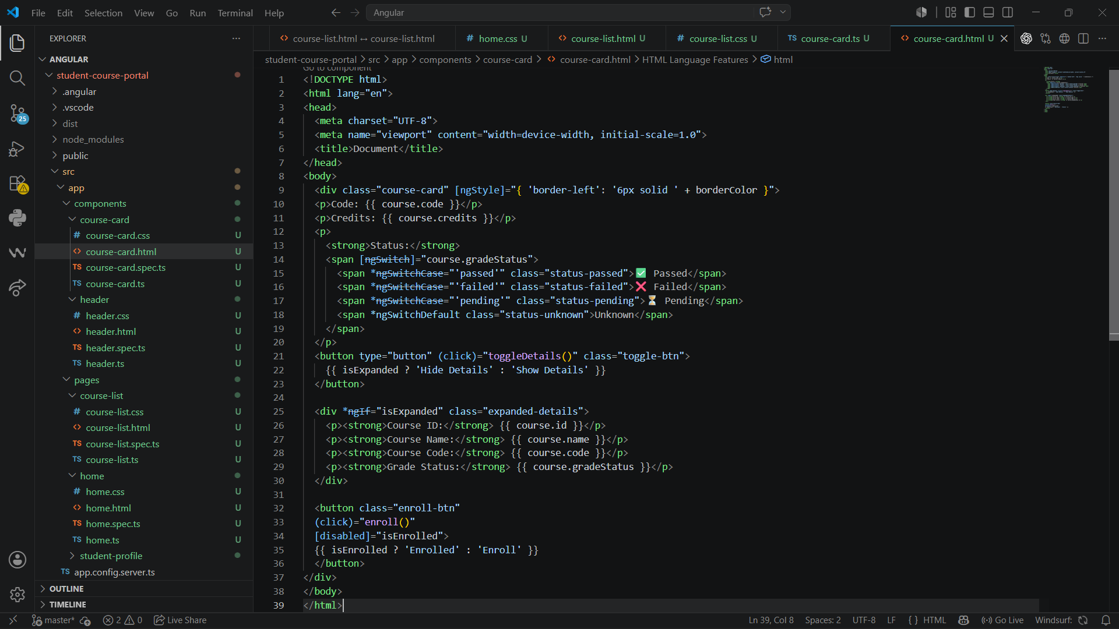

Course-card.ts:
Adding border color based on the status of the course
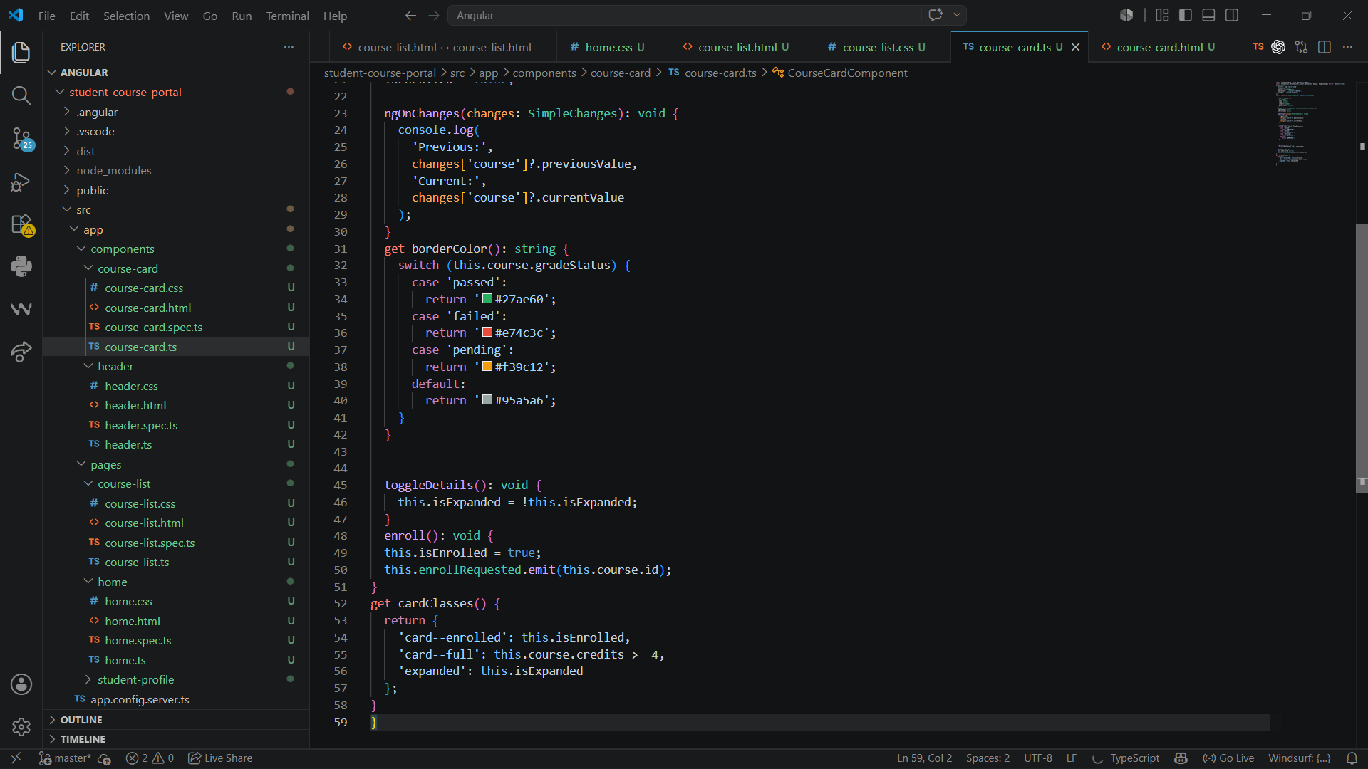
Course-card.css:
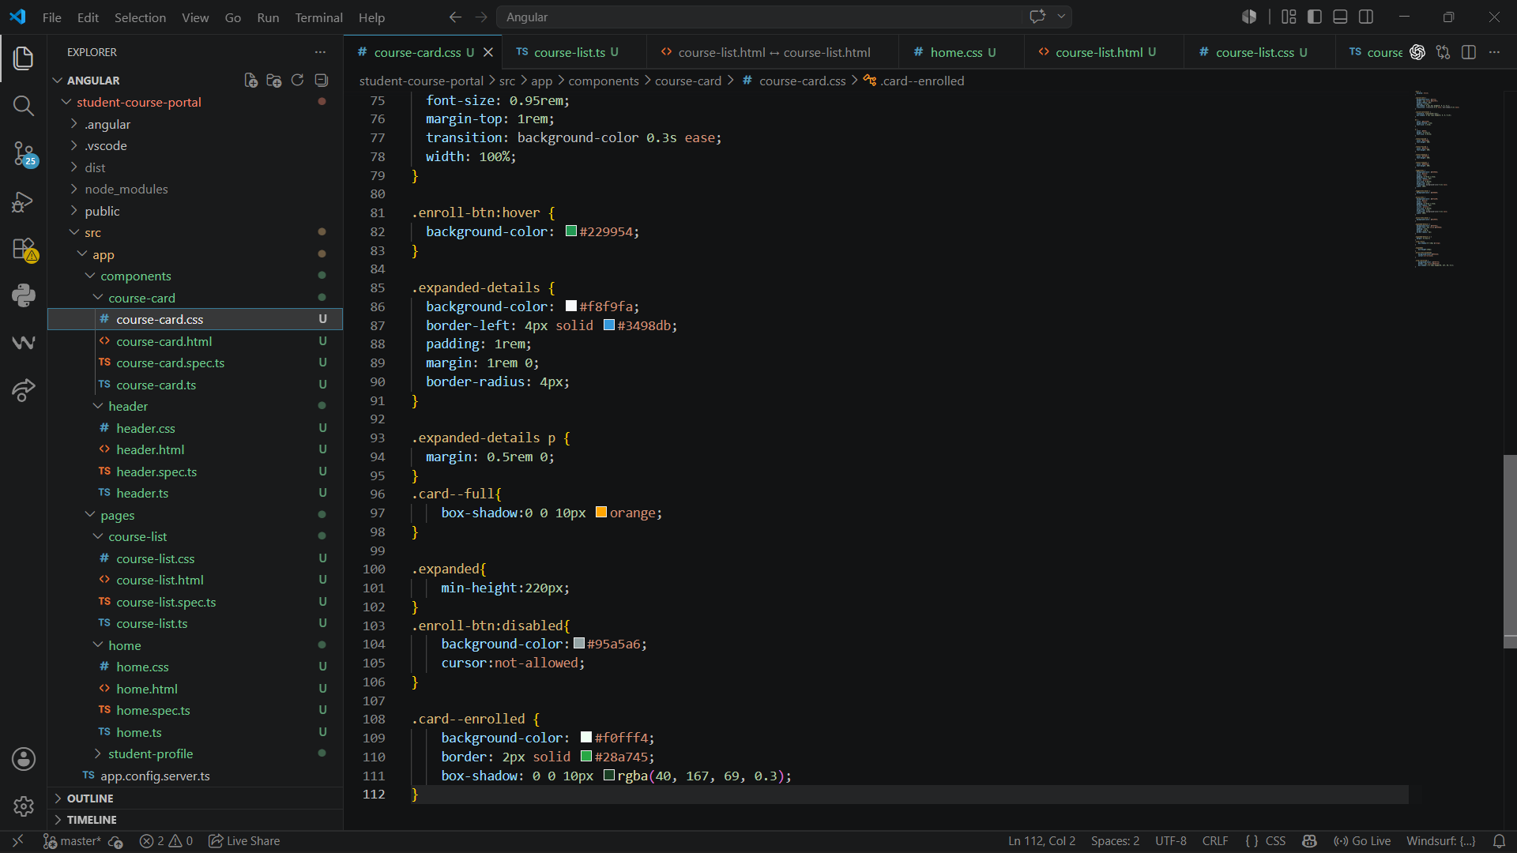

Output:
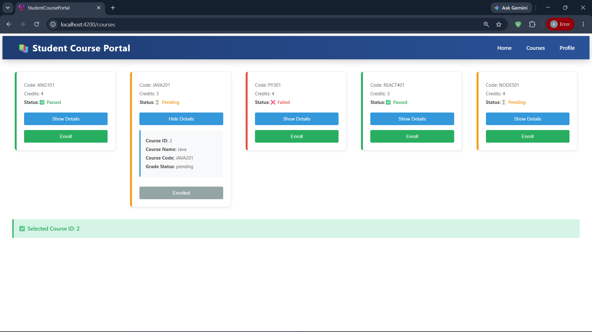
Task 3: Custom Directive and Custom Pipe
Goal: Build a reusable attribute directive and a custom pipe for the portal.
Highlights.ts
Added Directive for highting the course when hovering
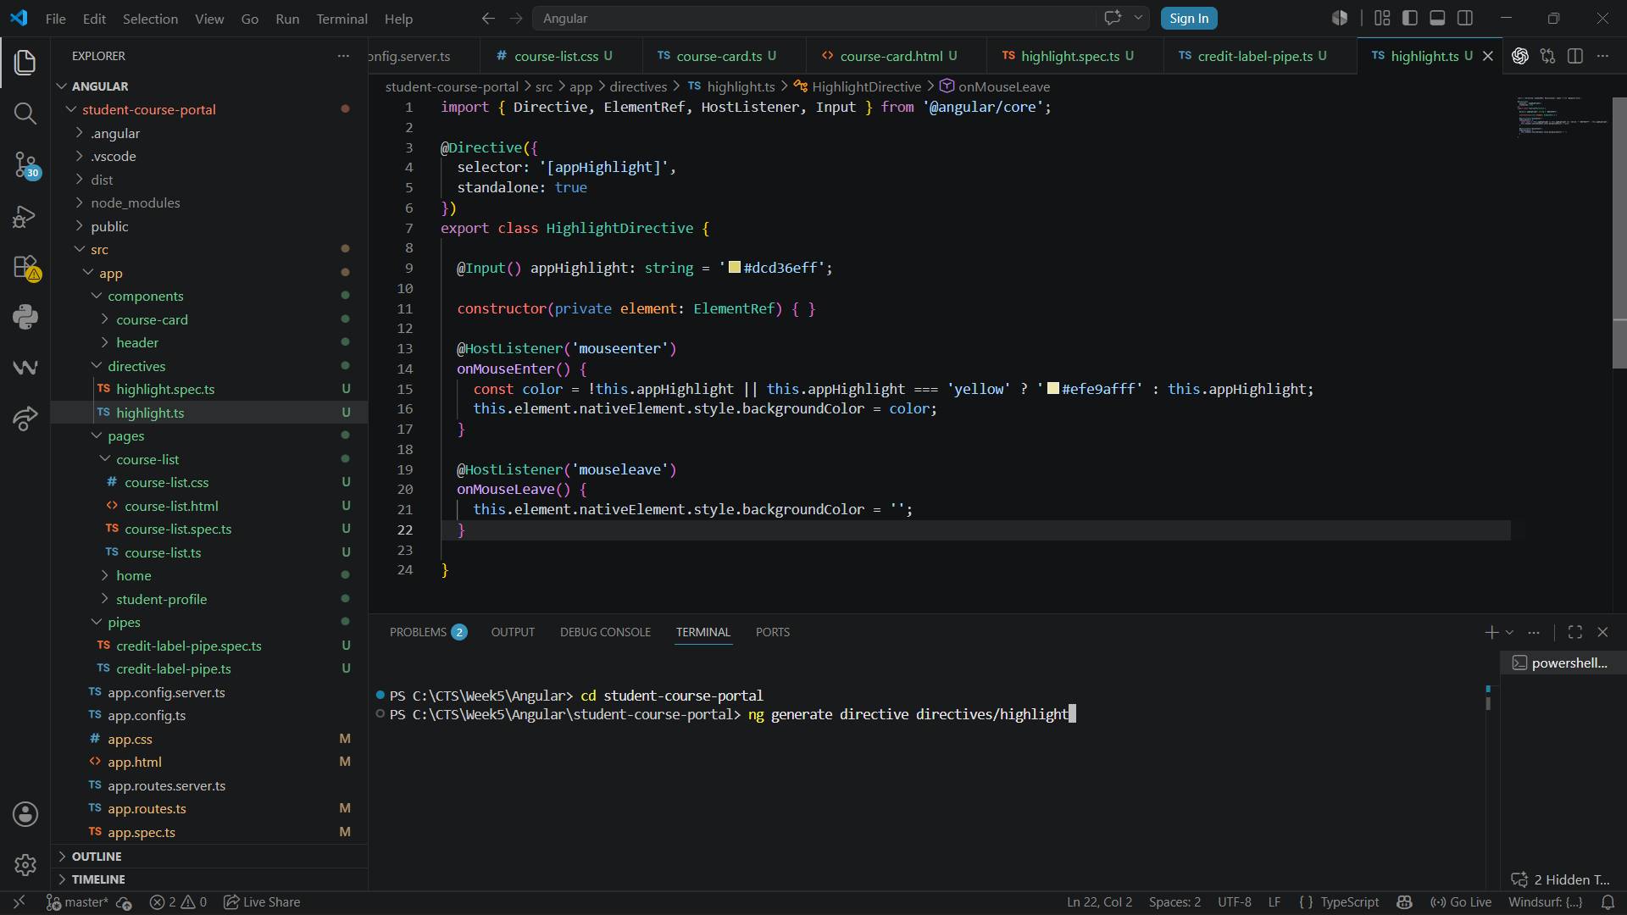

Course-list.html:
Adding apphighlight
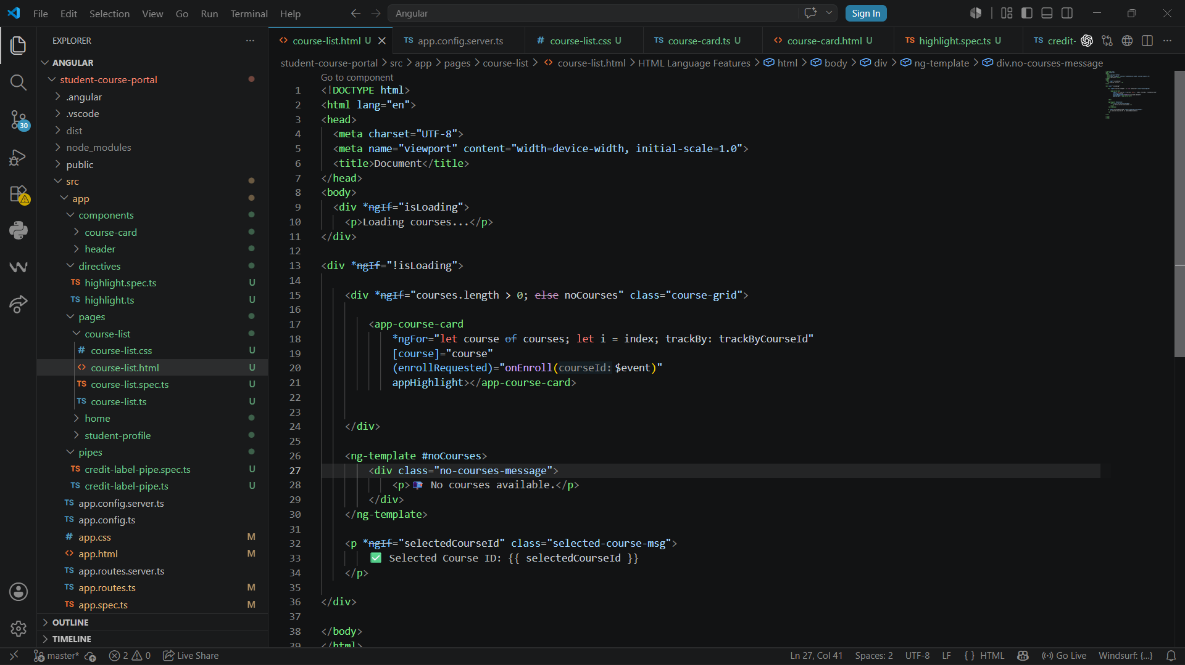
Credit-label-pipe.ts:
Declaring the credits based on the value present in the course List
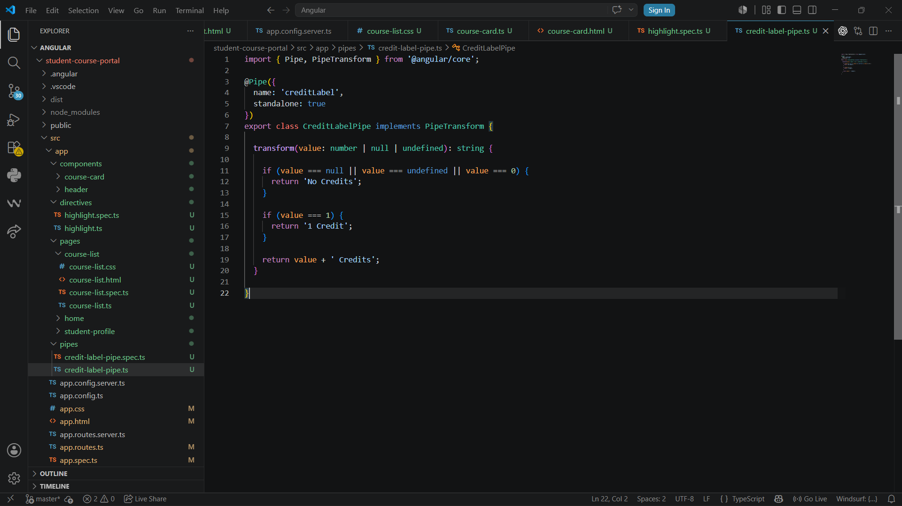

Output:
When the Course is hovered the yellow highlighting appears and Credits for the Course
